**Artículo 16S Segundo muestreo**

**Introducción**

**Metodología**

Site Description

Rhizosphere samples were collected from two mangroves: un manglar alterado, debido a … y un manglar conservado . Samples were transported on ice to the laboratory and stored at -20°C until DNA extraction.

Physicochemical analyses

Each sample was characterized physical and chemical according to Vanegas et al. (2013).

DNA extraction and 16S rRNA sequencing

From each sample, 0.5 g were subjected to DNA extraction using the PowerLyzer PowerSoil DNA Isolation Kit (MoBio® Laboratories Inc., Carlbasd, CA, USA) in accordance with the manufacturer’s protocol. The PCR amplification of bacterial 16S rRNA V3-V4 region was performed as described by Klindworth et al., (2013), with primers V3F (ACACTCTTTCCCTACACGACGCTCTTCCGATCTCCTACGGGNGGCWGCAG) and V4R (GTGACTGGAGTTCAGACGTGTGCTCTTCCGATCTGACTACHVGGGTATCTAATCC). The PCR products of the 16S rRNA were sequenced using 300 bp PE strategy on the Illumina MiSeq platform.

Processing of sequencing dataset

Sequencing data were processed using the software Mothur v 1.36.5 (Schloss et al., 2009). To minimize effects of sequencing errors, we trimmed sequences that contained more than one undetermined nucleotide (N), with more than six homopolymers, and those with the Q-score average below 25 in a window of 50pb. Sequences trimmed with length <250pb after proximal PCR primer were eliminated. To reduce the number of spurious sequences, we used a pre-clustering step (Huse et al., 2010) for noise reduction and Vsearch algorithm (Rognes et al., 2016) for chimeras elimination. Trimmed, high-quality reads were used to calculate an uncorrected distance matrix. The opticlust algorithm (Westcott and Schloss, 2017) was used to gather the sequences into OTUs at 97% of similarity. The OTUs taxonomical annotation was the consensus taxonomy of the sequences, which were identified using the Bayesian-RDP classifier (Wang et al., 2007) over SILVA reference database (Quast et al., 2013).

For the ecological and statistical analysis, the OTU count table was pre-processed to reduce spurious and chimeric OTUs. We kept an OTU when its read count was greater than one read in at least three sequencing libraries. The OTU counts were normalized according to the Cumulative-sum scaling method (Paulson et al., 2013). With the normalized counts, we used the R packages vegan (Oksanen et al., 2017) and metagenomeSeq (Paulson et al., 2013) to calculate the alpha and beta diversity and to identify the OTUs with differential abundance among the salinity gradient. The rarefaction curve and Shannon index was used to assess the diversity of the samples. Ordination analysis was used to explore the differences in community composition across sites and their physicochemical covariates. Canonical correspondence analysis (CCA) based on Bray-Curtis dissimilarity was used to assess differences in community composition across sites. The function envfit of vegan was used to perform a manova for categorical and linear correlations for continuous variables. To identify significant OTUs and genera with differential abundance among the salinity gradient, we used the zero-inflated Gaussian (ZIG) distribution mixture model (Paulson et al., 2013) accounting for physicochemical covariates (false discovery rate, FDR<10% and fold-change > 0.5).

Objetivo general: Determinar las diferencias taxonómicas entre manglares conservados y no alterados, el tipo de plantas y los físico químicos.

**Resultados**

*Fisicoquímicos*

Los parámetros fisicoquímicos del suelo que presentaron diferencias significativas entre las 18 muestras fueron CE, CO, NT, K, P, Cu, Fe, Mn, Zn, Arcilla, Limo, Arena y NO3 (Tabla 1). Sin embargo, sólo CE, P, Cu, Mn y Arena fueron los parámetros contrastantes entre los dos manglares (alterado y conservado). Decir en cada manglar cual fue superior.

Análisis de componentes principales a partir de las abundancias de filos y géneros presentan muestras agrupadas de acuerdo al tipo de manglar de procedencia y al mangle asociado a la rizósfera (Figura 1).

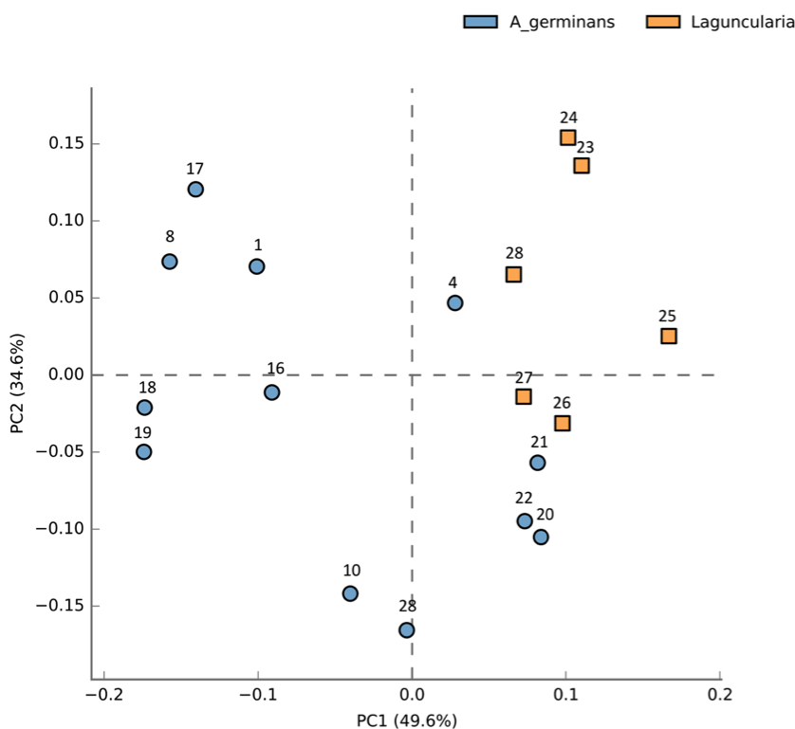

Altered mangrove

Conserved mangrove

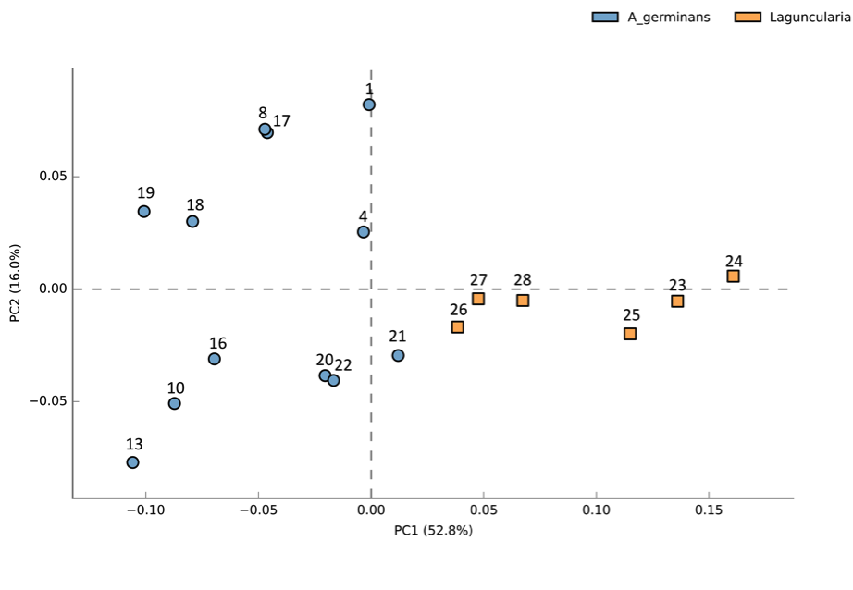

Altered mangrove

Conserved mangrove

A

B

Figure 1. PCA using abundances at the A) phylum level and B) genus level.

Table 1. Average values and standard errors (in parentheses) of chemical parameters of different soil samples from conserved and altered mangroves. P-values were calculated by using ANOVA statistical test, Tukey-Kramer post-hoc test and p-values corrected multiple by Benjamini-Hochberg FDR test correction.

|  |  |  |  |  |  |  |  |  |  |  |  |  |  |  |  |  |  |  |  |  |  |
| --- | --- | --- | --- | --- | --- | --- | --- | --- | --- | --- | --- | --- | --- | --- | --- | --- | --- | --- | --- | --- | --- |
| Groups | pH | CE | CO | NT | Ca | K | Mg | Na | CICE | P | S | Cu | Fe | Mn | Zn | B | Arcilla | Limo | Arena | NO3 | NH4 |
| Altered 1 | 7.23(0.17)b | 16.03(0.63)c | 0.51(0.06)a | 0.25(0.01)a | 4.48(0.5)de | 1.37(0.01)bc | 6.9(0.21)c | 15(0.15)c | 27.73(0.44)c | 120(0)a | 169.4(43.54)c | 3.58(0.2)b | 112.33(9.94)b | 40.4(4.56)b | 1.94(0.24)c | 2.41(0.1)b | 39.67(1.76)ab | 42(1.15)a | 19.33(1.76)b | 5.56(3.33)b | 2.09(1.06)a |
| Altered 2 | 7.16(0.14)b | 15.59(5.28)c | 0.68(0.07)ab | 0.21(0.02)ab | 3.37(0.22)e | 1.35(0.17)c | 6.34(0.39)c | 18.4(5.57)c | 29.47(5.92)c | 105.67(9.39)a | 168.58(81.61)c | 4.94(0.6)a | 156.33(5.78)a | 38.53(10.74)b | 2.85(0.5)c | 3.45(0.87)b | 39(5.29)ab | 34.67(4.81)ab | 27.33(2.4)b | 0(0)b | 1.84(0.92)a |
| Altered 3 | 7.52(0.03)b | 42.47(1.13)b | 0.51(0.02)ab | 0.2(0.03)ab | 6.28(0.59)cd | 1.74(0.03)ab | 13.93(0.07)b | 37.67(0.72)b | 59.6(0.31)b | 120(0)a | 635(107.04)bc | 3.69(0.02)ab | 168.67(9.06)a | 118.67(8.35)a | 1.89(0.01)c | 3.84(0.1)b | 49.67(0.67)a | 36.33(3.71)ab | 14(3.06)b | 0(0)b | 1.88(0.96)a |
| Conserved 1 | 7.1(0.02)b | 145.13(5.82)a | 2.42(0.19)a | 0.25(0)a | 8.25(0.59)bc | 2.07(0.06)a | 22.37(1.32)a | 81.9(4.33)a | 114.67(6.57)a | 41.33(1.08)b | 1415.67(203.56)a | 2.01(0.16)c | 81.53(2.77)bc | 7.23(0.51)c | 2.38(0.12)c | 7.91(0.07)a | 19.67(0.67)bc | 10.33(1.2)c | 70.67(1.76)a | 1(0.77)b | 6.91(0.53)a |
| Conserved 2 | 8.28(0.04)a | 54.8(0.46)b | 1.52(0.1)b | 0.14(0.02)b | 10.56(0.73)ab | 0.68(0.04)d | 5.54(0.06)c | 19.93(1.22)c | 36.7(1.92)c | 16.93(5.35)c | 195.33(33.67)c | 0.2(0.03)d | 25.29(15.51)d | 1.61(0.58)c | 546.67(33.77)a | 4.06(0.33)b | 17(14)bc | 16.67(2.67)bc | 67.33(16.67)a | 21(3.37)a | 1.37(0.69)a |
| Conserved 3 | 8.45(0.01)a | 133.47(2.49)a | 1.9(0.12)b | 0.16(0.02)b | 13.23(0.65)a | 1.38(0.06)bc | 13.37(1.13)b | 50.83(4.56)b | 78.8(6.29)b | 22.93(0.73)bc | 798.33(36.66)b | 0.43(0.02)d | 40.03(2.67)cd | 3.72(0.13)c | 183.33(8.19)b | 4.38(0.59)b | 7.67(0.67)c | 16.67(9.68)bc | 76.67(9.4)a | 19.9(2)a | 4.24(2.12)a |
| P-Value | 0.01 | 5.E-06 | 8.E-04 | 2.E-03 | ns | 2.E-05 | ns | ns | ns | 9.E-06 | ns | 6.E-06 | 2.E-06 | 1.E-08 | 0.02 | ns | 3.E-06 | 3.E-04 | 0.02 | 0.03 | ns |
| P-Value(Corrected) | 0.03 | 3.E-05 | 2.E-03 | 4.E-03 | ns | 8.E-05 | ns | ns | ns | 3.E-05 | ns | 3.E-05 | 2.E-05 | 2.E-07 | 0.03 | ns | 2.E-05 | 9.E-04 | 0.04 | 0.04 | ns |

Table 2. Average values and standard errors (in parentheses) of genera abundances of different soil samples from conserved and altered mangroves. P-values were calculated by using ANOVA statistical test, Tukey-Kramer post-hoc test and p-values corrected multiple by Benjamini-Hochberg FDR test correction.

|  |  |  |  |  |  |  |  |
| --- | --- | --- | --- | --- | --- | --- | --- |
| **Géneros** | **p-values (Corrected)** | **Altered_Mangrove_1** | **Altered_Mangrove_2** | **Altered_Mangrove_3** | **Conserved_Mangrove_1** | **Conserved_Mangrove_2** | **Conserved_Mangrove_3** |
|  |  | A | A | A | A | L | L |
| Halobacillus | 3.E-05 | 2.13(0.64)b | 0.23(0.23)b | 1.73(0.26)b | 9.93(1.49)ab | 22.96(6.69)a | 13.52(4.24)ab |
| Salinibacter | 8.E-05 | 0.76(0.22)b | 0.31(0.31)b | 0(0)b | 8.97(2.56)b | 42.68(9.76)a | 20.15(6.21)ab |
| Pir4_lineage | 1.E-04 | 0.6(0.35)b | 0.25(0.25)b | 0(0)b | 1.49(0.37)ab | 2.44(1.21)ab | 3.43(0.32)a |
| Pontibacillus | 2.E-04 | 3.32(1.2)bc | 0.45(0.45)c | 1.41(0.34)c | 3.09(0.56)bc | 7.73(1.8)ab | 9.42(0.99)a |
| Bythopirellula | 3.E-04 | 0.52(0.28)a | 0.23(0.23)a | 3.84(2.72)a | 1.75(0.1)a | 11.66(5.4)a | 13.8(7.62)a |
| Clostridium_sensu_stricto | 8.E-04 | 30.95(2.63)a | 53.67(7.77)a | 40.95(13.16)a | 0(0)b | 0(0)b | 0.13(0.13)b |
| Nitrolancea | 1.E-03 | 1.17(0.38)c | 0.31(0.31)c | 1.55(0.43)c | 40.28(8.49)b | 67.56(13.64)ab | 79.51(4.86)a |
| Dichotomicrobium | 2.E-03 | 14.96(9.26)c | 11.47(2.67)c | 33.54(6.96)bc | 18.12(1.45)c | 109.07(3.09)a | 53.13(5.25)b |
| Sva0081_sediment_group | 3.E-03 | 81.33(22.34)b | 244.05(111.12)b | 91.05(8.43)b | 156.73(22.19)b | 861.99(109.11)a | 190.56(17.59)b |
| Urania.1B.19_marine_sediment_group | 5.E-03 | 0(0)b | 0(0)b | 0(0)b | 0.68(0.27)ab | 2.58(0.82)a | 2.61(0.93)a |
| Blastopirellula | 0.01 | 43.66(20.9)a | 3.14(0.3)a | 6.82 (4.49)a | 11.72(4.15)a | 63.23(35.07)a | 66.6(21.9)a |
| Candidatus_Thiobios | 0.01 | 0.16(0.16)a | 0(0)a | 0(0)a | 0.27(0.13)a | 4.68(3.68)a | 2.48(0.97)a |
| Methyloceanibacter | 0.02 | 0.92(0.17)a | 1.44(1.01)a | 2.57(0.82)a | 1.1(0.7)a | 6.03(3.07)a | 3.27(0.56)a |
| Paenibacillus | 0.03 | 36.54(5.54)bc | 22(4.91)c | 47.84(12.01)bc | 49.39(2.89)bc | 192(20.2)a | 83.38(8.58)b |
| Crossiella | 0.03 | 2.65(0.9)c | 6.71(5.14)bc | 5.38(2.51)c | 12.59(1.6)bc | 36(6.28)a | 23.02(2.4)ab |
| Nitrosococcus | 0.04 | 0(0)b | 0(0)b | 0(0)b | 9.91(4)ab | 13.43(5.2)ab | 16.39(3.46)a |
| Portibacter | 0.04 | 3.71(1.32)b | 17.5(13.12)ab | 3.28(3.28)b | 5.84(2.3)ab | 57.87(22.98)a | 15.86(5.94)ab |
| Tumebacillus | 0.04 | 1.17(0.39)b | 2.72(0.68)b | 2.44(0.52)b | 4.17(0.42)b | 23.54(5.98)a | 3.55(0.67)b |
| Rhodopirellula | 0.04 | 0.2(0.2)c | 0(0)c | 0(0)c | 0.8(0.38)bc | 8.52(2.71)a | 6.83(1.53)ab |
| Deferrisoma | 0.04 | 7.99(6.44)b | 30.86(11.81)b | 9.25(1.8)b | 57.12(5.3)b | 247.32(77.28)a | 118.18(36.12)ab |
| Oceanobacillus | 0.04 | 0(0)a | 0(0)a | 2.94(1.39)a | 0.53(0.34)a | 10.55(5.18)a | 3.18(1.44)a |
| Rhodomicrobium | 0.05 | 21.1(7.24)b | 12.63(10.34)b | 13.62(3.6)b | 35.62(1.37)ab | 74.76(5.54)a | 58.93(19.23)ab |

**Discusión**

Caracterizaciòn físico química. Solicitar a orson los físico químicos vs los otus.

Los manglares alterados y conservados fueron separados por ww xxxx

La proporción de carbono orgánico y nitrógeno total (C/N) fue mayor en el manglar conservado pero menor en el manglar alterado. Por lo tanto, esta proporción C/N más alta en el manglar conservado puede estar relacionado a una mayor proporción de detritos de plantas de mangle (Castro-Rodríguez et al., 2018).

El contenido de fósforo fue significativamente mayor en el manglar alterado.

El manglar alterado presentó mayores niveles de los metales cubre, Fe y Mn en comparación al manglar conservado. De acuerdo a Sander et al. (2012), las altas concentraciones de Fe y Mn en manglares tiene influencia directa con la subida del nivel del mar. En otro trabajo, las concentraciones de Mn se debió a geological nature formations and presence of high mountains of basic igneous rocks (Shriadah et al., 1999).

El manglar conservado es significativamente más arenoso que el manglar alterado.

Cuales son los phylum --generos/familias-- con mayores abundancias en cada manglar?

Existen diferencias en la diversidad taxonomica entre manglares alteradso y conservados?

Los género *Halobacillus, Salinibacter, Pontibacillus, Nitrolancea* y *Rhodomicrobium* presentaron mayores abundancias en el manglar conservado. El género *Halobacillus* ha sido reportado como promotor de crecimiento vegetal en ambientes salinos (Desale *et al*., 2014). Pontibacillus y Salinibacter son géneros comúnmente aislados de ambientes moderadamente salinos e hipersalinos respectivamente (Kheiralla et al., 2013; Bardavid et al., 2007). *Rhodomicrobium* ha sido reportado en ambientes termales (Ainon *et al*., 2006), mientras que miembros del género *Nitrolancea* oxidadores de nitrito han sido aislados de bioreactores (Sorokin et al., 2014).

Existen diferencias en la diversidad taxonomica entre Avicennia y Lacuncularia?.

Existen diferencias en la diversidad taxonomica entre Avicennia del manglar alterado y el conservado?.

**Bibliografía**

Vanegas, J., Landazabal, G., Melgarejo, L.M., Beltran, M., Uribe-Vélez, D., 2013. 630Structural and functionalcharacterization of the microbial communities associated 631with the upland and irrigated rice rhizospheres in a neotropical Colombian savannah. 632European Journal of Soil Biology 55, 1–8. doi:10.1016/j.ejsobi.2012.10.008

Castro-Rodríguez, E., León-Luna, I., & Pinedo-Hernández, J. (2018). Biogeochemistry of mangrove sediments in the Swamp of Mallorquin, Colombia. *Regional Studies in Marine Science*, *17*, 38-46.

Desale, P., Patel, B., Singh, S., Malhotra, A., & Nawani, N. (2014). Plant growth promoting properties of Halobacillus sp. and Halomonas sp. in presence of salinity and heavy metals. *Journal of basic microbiology*, *54*(8), 781-791.

Kheiralla, Z. H., Ashour, S. M., Rushdy, A. A., & Ahmed, H. A. (2013). Characterization of biosurfactants produced by Halobacillus dabanensis and Pontibacillus chungwhensi isolated from oil-contaminated mangrove ecosystem in Egypt. *Applied biochemistry and microbiology*, *49*(3), 263-269.

Bardavid, R. E., Ionescu, D., Oren, A., Rainey, F. A., Hollen, B. J., Bagaley, D. R., ... & McKay, C. (2007). Selective enrichment, isolation and molecular detection of Salinibacter and related extremely halophilic Bacteria from hypersaline environments. *Hydrobiologia*, *576*(1), 3-13.

Ainon, H., Tan, C. J., & Vikineswary, S. (2006). Biological characterization of Rhodomicrobium vannielii isolated from a hot spring at Gadek, Malacca, Malaysia. *Malaysian Journal of Microbiology*, *2*(1), 15-21.

Sorokin, D. Y., Vejmelkova, D., Lücker, S., Streshinskaya, G. M., Rijpstra, W. I. C., Damsté, J. S. S., ... & Daims, H. (2014). Nitrolancea hollandica gen. nov., sp. nov., a chemolithoautotrophic nitrite-oxidizing bacterium isolated from a bioreactor belonging to the phylum Chloroflexi. *International journal of systematic and evolutionary microbiology*, *64*(6), 1859-1865.

Sanders, C. J., Santos, I. R., Barcellos, R., & Silva Filho, E. V. (2012). Elevated concentrations of dissolved Ba, Fe and Mn in a mangrove subterranean estuary: Consequence of sea level rise?. *Continental Shelf Research*, *43*, 86-94.

Shriadah, M. M. A. (1999). Heavy metals in mangrove sediments of the United Arab Emirates shoreline (Arabian Gulf). Water, Air, and Soil Pollution, 116(3-4), 523-534. ISO 690